<https://www.w3schools.com/bootstrap/bootstrap_tabs_pills.asp>

<ul class="list-inline">  
  <li><a href="#">Home</a></li>  
  <li><a href="#">Menu 1</a></li>  
  <li><a href="#">Menu 2</a></li>  
  <li><a href="#">Menu 3</a></li>  
</ul>



<ul class="nav nav-tabs">

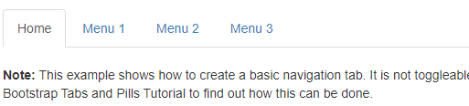

Tabs With Dropdown Menu

<ul class="nav nav-tabs">  
  <li class="active"><a href="#">Home</a></li>  
  <li class="dropdown">  
    <a class="dropdown-toggle" data-toggle="dropdown" href="#">Menu 1  
    <span class="caret"></span></a>  
    <ul class="dropdown-menu">  
      <li><a href="#">Submenu 1-1</a></li>  
      <li><a href="#">Submenu 1-2</a></li>  
      <li><a href="#">Submenu 1-3</a></li>  
    </ul>  
  </li>  
  <li><a href="#">Menu 2</a></li>  
  <li><a href="#">Menu 3</a></li>  
</ul>

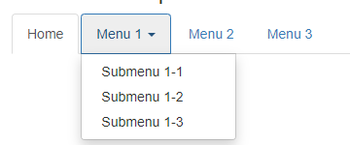

<ul class="nav nav-pills">  
  <li class="active"><a href="#">Home</a></li>  
  <li><a href="#">Menu 1</a></li>  
  <li><a href="#">Menu 2</a></li>  
  <li><a href="#">Menu 3</a></li>  
</ul>

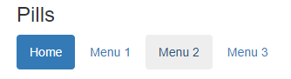

Vertical Pills

<ul class="nav nav-pills nav-stacked">  
  <li class="active"><a href="#">Home</a></li>  
  <li><a href="#">Menu 1</a></li>  
  <li><a href="#">Menu 2</a></li>  
  <li><a href="#">Menu 3</a></li>  
</ul>

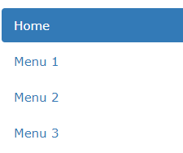

Vertical pills with dropdown

<ul class="nav nav-pills nav-stacked">  
  <li class="active"><a href="#">Home</a></li>  
  <li class="dropdown">  
    <a class="dropdown-toggle" data-toggle="dropdown" href="#">Menu 1  
    <span class="caret"></span></a>  
    <ul class="dropdown-menu">  
      <li><a href="#">Submenu 1-1</a></li>  
      <li><a href="#">Submenu 1-2</a></li>  
      <li><a href="#">Submenu 1-3</a></li>  
    </ul>  
  </li>  
  <li><a href="#">Menu 2</a></li>  
  <li><a href="#">Menu 3</a></li>  
</ul>

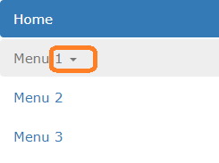

TOOGLE !!!

<ul class="nav nav-tabs">  
  <li class="active"><a data-toggle="tab" href="#home">Home</a></li>  
  <li><a data-toggle="tab" href="#menu1">Menu 1</a></li>  
  <li><a data-toggle="tab" href="#menu2">Menu 2</a></li>  
</ul>  
  
<div class="tab-content">

  <div id="home" class="tab-pane fade in active">  
    <h3>HOME</h3>  
    <p>Some content.</p>  
  </div>

  <div id="menu1" class="tab-pane fade">  
    <h3>Menu 1</h3>  
    <p>Some content in menu 1.</p>  
  </div>

  <div id="menu2" class="tab-pane fade">  
    <h3>Menu 2</h3>  
    <p>Some content in menu 2.</p>  
  </div>

</div>

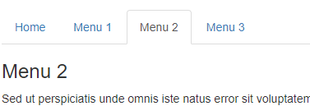

Toogle dynamic pills

<ul class="nav nav-pills">  
  <li class="active"><a data-toggle="pill" href="#home">Home</a></li>  
  <li><a data-toggle="pill" href="#menu1">Menu 1</a></li>  
  <li><a data-toggle="pill" href="#menu2">Menu 2</a></li>  
</ul>  
  
<div class="tab-content">

  <div id="home" class="tab-pane fade in active">  
    <h3>HOME</h3>  
    <p>Some content.</p>  
  </div>

  <div id="menu1" class="tab-pane fade">  
    <h3>Menu 1</h3>  
    <p>Some content in menu 1.</p>  
  </div>

  <div id="menu2" class="tab-pane fade">  
    <h3>Menu 2</h3>  
    <p>Some content in menu 2.</p>  
  </div>

</div>

